RUSHAD AUSTIN
Zoroastrian Association of Quebec
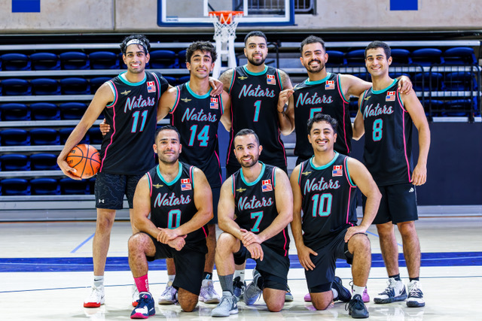This past June, I participated in my first-ever Z Games, and it was amazing! Flying from Montreal to Sacramento and walking onto the UC Davis campus filled me with excitement and joy. After months of anticipation and training, I was ready to compete and finally meet up with people I had been looking forward to seeing. As the sole participant from the Zoroastrian Association of
Quebec, I was proud to represent my community, eager to compete and hopefully bring back a medal.
